WASHINGTON STATE BOARD OF REGISTERED SANITARIANS
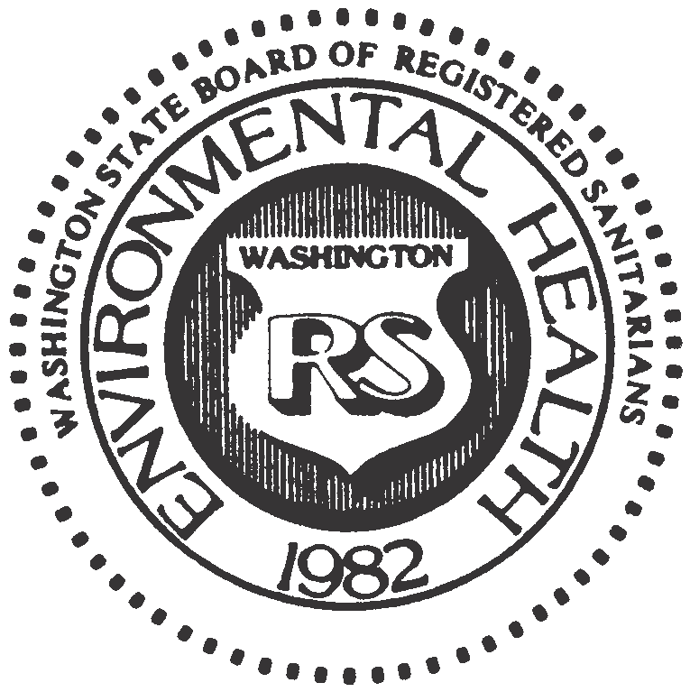

P. O. Box 384
Snohomish, Washington 98291
(360) 659-8432
wsbrs.secretary@gmail.com

APPLICATION AFFIDAVIT

State of __________________________________

County of ________________________________

_____________________________________________, being first duly sworn, deposes and says: I, the applicant named in this application, am of good moral character and have read the contents hereof, and to the best of my knowledge and belief the statements in my application for registration are true in substance and effect and are made in good faith.

_____________________________________________________________
Signature of Applicant

Subscribed and sworn to before me this __________ day of _______________, 20____.

______________________________________________________________
Signature of Notary Public

Notary Public in and for the State of __________________________________

(Seal)

