WASHINGTON STATE BOARD OF REGISTERED SANITARIANS
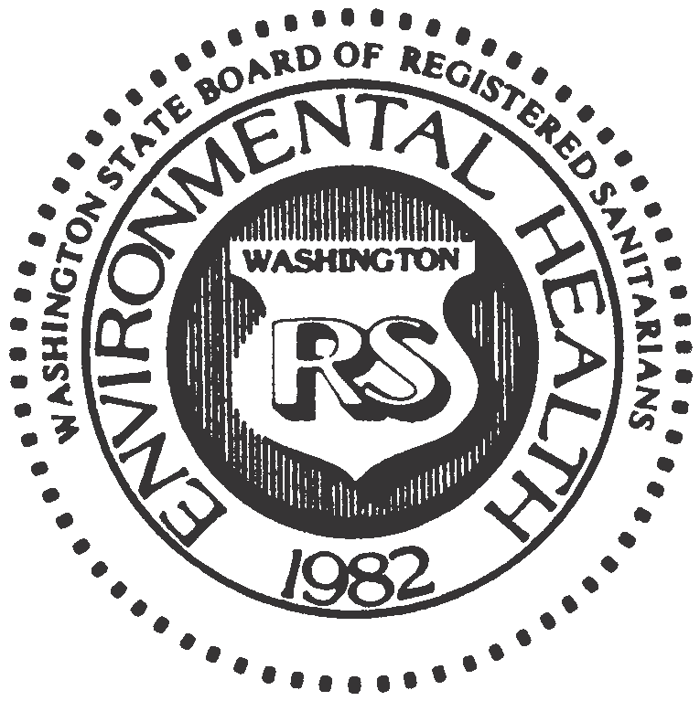

P. O. Box 384, Snohomish, Washington 98291 (360) 659-8432
wsbrs.secretary@gmail.com

WASHINGTON STATE BOARD OF REGISTERED SANITARIANS
ANNUAL MEMBERSHIP MEETING
TUESDAY, MAY 9th, 2023
7:00am

[In-person and MS Teams Conference Call]

MEETING MINUTES

- Introduction of Current Board Members
Board members Sammy Berg, Rob Eastman, and Lars Richins were present and board staff Toni Plemel attended virtually.
- Review Minutes of May 9th, 2022, Annual Membership Meeting
Meeting minutes were reviewed and approved, 3-0.
- Treasurer’s Report
- Current year budget report
- Proposed 2023/2024 budget adoption, approved, 3-0.
- Board Position – Vacany
- The secretary position will be vacant with the outgoing President. Discussed needing to fill the vacancy and the 3 year term with first year as Secretary, 2nd year as Vice President and final year as President.
- Comments by vacating President, Future of WBRS
- Envisions moving toward online payments and online CEU submittals to help both board staff and members.
- Review criteria for sitting in on the exam and finding the balance between opening opportunities for potential candidates while maintain the integrity and brand of what it means to be a Registered Sanitarian.
- NEHA petition to congress to require credentialing.
- Board Position – Filled
The Secretary position will be filled by Katie Lott after discussion and interest was expressed.

