WASHINGTON STATE BOARD OF REGISTERED SANITARIANS
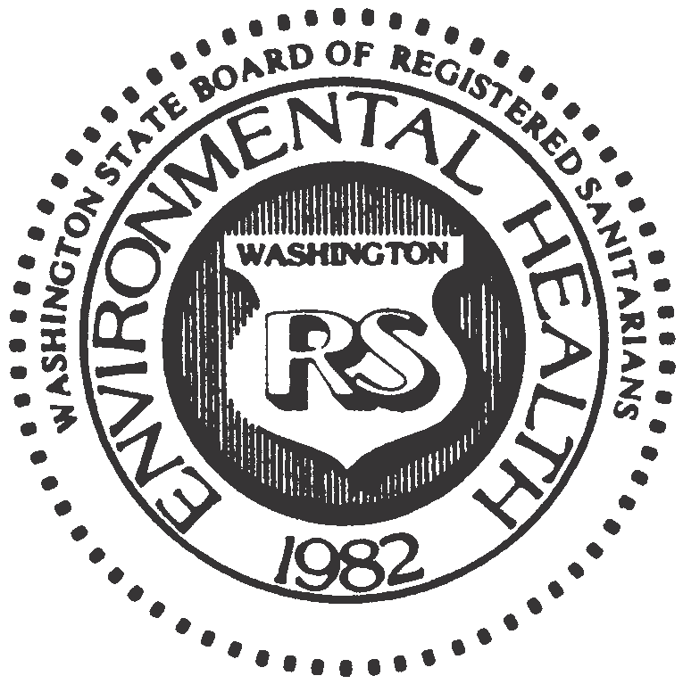

P. O. Box 384, Snohomish, Washington 98291 (360) 659-8432
wsbrs.secretary@gmail.com

WASHINGTON STATE BOARD OF REGISTERED SANITARIANS
ANNUAL MEMBERSHIP MEETING
THURSDAY JUNE 30th, 2022
7:00 – 8:30 AM

[In-person and MS Teams Conference Call]

MEETING MINUTES

[Minutes from the June 2022 meeting were not retained. These minutes reflect recollections of those present at the meeting. Apologies to the membership.]
- Introduction of Current Board Members
Board members Sammy Berg and Rob Eastman, and board staff Toni Plemel were present.
- Review Minutes of May 26th, 2021 Annual Membership Meeting
Meeting minutes were reviewed and approved, 2-0.
- Treasurer’s Report
- Current year budget report
- Proposed 2022/2023 budget was reviewed and approved, 2-0, with acknowledgement that adjustments may be needed during the budget period and such adjustments will be communicated to the board.
- Board Position – Vacant Position
The Secretary position is vacant at this time and interested sanitarians were invited to contact the board about the opportunity to join.
- Executive Secretary Contract Renewal
The three-year contract with Toni Plemel expires this year and needs to be reviewed and approved by board.
- Incoming Chair Comments
The collaboration between the NEHA and the WSEHA to host the 2022 Annual Education Conference in Spokane, WA is an awesome opportunity for Washington sanitarians. The ability to interact with and learn from other sanitarians, vendors, and educational program staff at the national level is not to be missed. The WSEHA Board and the AEC Planning Committee deserve many kudos for their efforts to put on a great professional opportunity for our members.

